The Islamia University of Bahawalpur

**U**niversity **C**ollege of **E**ngineering **&T**echnology **D**epartment of **C**omputer **S**ystem Engineering

|  |  |  |
| --- | --- | --- |
| **LAB MANUAL** | **SIGNAL AND SYSTEMS EE-311** | **5thSemester** |

**LAB EXPERIMENT # 13**

**Performance Analysis of Basic Filters**

|  |  |
| --- | --- |
| **Student Name:** | **Roll No:** |
| **Lab Instructor Signatures:** | **Date:** |

## OBJECTIVE:

* To study the performance of basic filters
* Elliptic filter

# Elliptic filter:

**Syntax:**

[b,a] = ellip(n,Rp,Rs,Wp)

[b,a] = ellip(n,Rp,Rs,Wp,ftype) [z,p,k] = ellip( )

[A,B,C,D] = ellip( )

[[b,a](https://www.mathworks.com/help/signal/ref/ellip.html#outputarg_ba)] = ellip([n](https://www.mathworks.com/help/signal/ref/ellip.html#inputarg_n),[Rp](https://www.mathworks.com/help/signal/ref/ellip.html#inputarg_Rp),[Rs](https://www.mathworks.com/help/signal/ref/ellip.html#inputarg_Rs),[Wp](https://www.mathworks.com/help/signal/ref/ellip.html#inputarg_Wp)) returns the transfer function coefficients of an nth-order lowpass digital elliptic filter with normalized passband edge frequency Wp. The resulting filter has Rp decibels of peak-to-peak passband ripple and Rs decibels of stopband attenuation down from the peak passband value.

[[b,a](https://www.mathworks.com/help/signal/ref/ellip.html#outputarg_ba)] = ellip([n](https://www.mathworks.com/help/signal/ref/ellip.html#inputarg_n),[Rp](https://www.mathworks.com/help/signal/ref/ellip.html#inputarg_Rp),[Rs](https://www.mathworks.com/help/signal/ref/ellip.html#inputarg_Rs),[Wp](https://www.mathworks.com/help/signal/ref/ellip.html#inputarg_Wp),[ftype](https://www.mathworks.com/help/signal/ref/ellip.html#inputarg_ftype)) designs a lowpass, highpass, bandpass, or bandstop elliptic filter, depending on the value of ftype and the number of elements of Wp. The resulting bandpass and bandstop designs are of order 2n.

## Lowpass Elliptic Transfer Function

**Example**: Design a 6th-order lowpass elliptic filter with 5 dB of passband ripple, 40 dB of stopband attenuation, and a passband edge frequency of 300 Hz, which, for data sampled at 1000 Hz, corresponds to 0.6𝞹 rad/sample. Plot its magnitude and phase responses. Use it to filter a 1000-sample random signal.

**Code:**

[b,a] = ellip(6,5,40,0.6);

freqz(b,a)

dataIn = randn(1000,1); dataOut = filter(b,a,dataIn);

## Output:

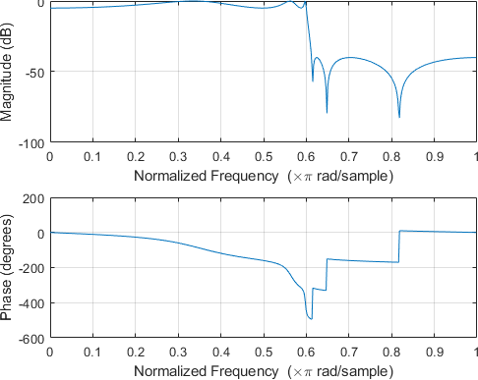

1. **Bandstop Elliptic Filter**

**Example**: Design a 6th-order elliptic bandstop filter with normalized edge frequencies of 0.2𝞹 and 0.6𝞹 rad/sample, 5 dB of passband ripple, and 50 dB of stopband attenuation. Plot its magnitude and phase responses. Use it to filter random data.

**Code:**

[b,a] = ellip(3,5,50,[0.2 0.6],'stop'); freqz(b,a)

## Highpass Elliptic Filter

**Example**: Design a 6th-order highpass elliptic filter with a passband edge frequency of 300 Hz, which, for data sampled at 1000 Hz, corresponds to 0.6𝞹 rad/sample.

Specify 3 dB of passband ripple and 50 dB of stopband attenuation. Plot the magnitude and phase responses. Convert the zeros, poles, and gain to second-order sections for use by fvtool.

**Code:**

[z,p,k] = ellip(6,3,50,300/500,'high'); sos = zp2sos(z,p,k); fvtool(sos,'Analysis','freq')

## Bandpass Elliptic Filter

**Example**: Design a 20th-order elliptic bandpass filter with a lower passband frequency of 500 Hz and a higher passband frequency of 560 Hz. Specify a passband ripple of 3 dB, a stopband attenuation of 40 dB, and a sample rate of 1500 Hz. Use the state-space representation. Design an identical filter using designfilt.

**Code:**

**Task**

**Low Pass Filter:**

* A low-pass filter is a filter that passes signals with a frequency lower than a certain cutoff frequency and attenuates signals with frequencies higher than the cutoff frequency. The amount of attenuation for each frequency depends on the filter design. The filter is sometimes called a highcut filter, or treble cut filter in audio applications.

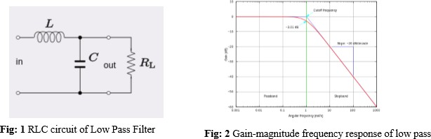

**High Pass Filter**:

A high-pass filter is an electronic filter that passes signals with a frequency higher than a certain cutoff frequency and attenuates signals with frequencies lower than the cutoff frequency. The amount of attenuation for each frequency depends on the filter design.

The simple first-order electronic high-pass filter shown in Figure 1 is implemented by placing an input voltage across the series combination of a capacitor and a resistor and using the voltage across the resistor as an output. The product of the resistance and capacitance (R×C) is the time constant.

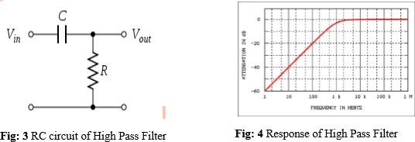

# Task:

https://www.mathworks.com/help/examples/signal/win64/ComparisonOfAnalogIIRLowpassFiltersEExample_01.png**Q**) Design a 5th-order analog Butterworth lowpass filter with a cutoff frequency of 2 GHz. Multiply by to convert the frequency to radians per second. Compute the frequency response of the filter at 4096 points.